**PATENT APPLICATION**

**Applicant**

|  |  |  |  |
| --- | --- | --- | --- |
| Inventor Details | Name | Address/College Affiliation | District |
| 1st Applicant | NITTE (Deemed to be University) | Nitte Deemed to be University, 6th Floor, University Enclave, Medical Sciences Complex, Deralakatte, Mangalore, Karnataka 575018 | Dakshina  Kannada |

**Inventor**

|  |  |  |  |  |  |  |  |
| --- | --- | --- | --- | --- | --- | --- | --- |
| **Inventor Details** | **Name** | **Mobile No.** | **Email ID** | **Gender** | **Address/College Affiliation** | **District** | **Signature** |
| 1st inventor | Chaithra S Nayak | 9148313775 | nayakchaithra5@gmail.com | Female | Nitte Deemed to be University | Udupi |  |
| 2nd Inventor | Khushi Shetty | 9945809021 | shettykhushi17@gmail.com | Female | Nitte Deemed to be University | Udupi |  |
| 3rd Inventor | Niharika  Shetty | 7619332565 | niharikaaashetty@gmail.com | Female | Nitte Deemed to be University | Udupi |  |
| 4th Inventor |  |  |  |  |  |  |  |
| 5th Inventor |  |  |  |  |  |  |  |
| 6th Inventor |  |  |  |  |  |  |  |

*Any number of inventors can be added

**Invention Disclosure Form**

**Description of Invention**

Q.1 – Have you ever disclosed your invention to your friends/family or published it in journals? Any presentation/pitch you would have made regarding your invention?

Ans. – No

Q.2 – Provide a short brief on the problem your invention is trying to solve.

Ans. – Our invention addresses a significant safety issue: the danger of current leakage in electric poles. This problem originates from a faulty insulation condition, damaged wiring, or even environmental factors such as rain, which enables a pole to become electrified. In such circumstances, it is rather dangerous and may cause grave electric shocks among nearby people and animals. Current detection methods are mostly manual and do not alert people to the presence of such hazards at any given time. Our system is therefore a smart, IoT-based solution designed to detect such hazards quickly and alert people in real-time, help prevent accidents, and save lives.

Q.3 – Do you know any prior inventions that are currently targeting the same problem you are trying to solve?

Ans. – Yes

Q.4 – Title of the Invention (Provide a title fitting the technical description of the invention and not a brand name)

Ans. – Smart IoT System for Detecting Current Leakage in Electric Poles and Shock Prevention

Q.5 – Materials/Apparatus/Dimensions/Formulae/Components used for the preparation of invention along with their working in the invention (Depending on your invention)

1. **Arduino Uno**: Acts as the central controller, processes sensor data, and triggers alerts based on thresholds.
2. **Voltage Sensor Module**: Detects voltage to identify current leakage.
   * **Formula**:
   * **Working**: Continuously monitors voltage and sends data to Arduino.
3. **Ultrasonic Sensor**: Detects proximity of individuals or animals.
   * **Formula**: d=(v*t)/2.
   * **Working**: Warns when someone is within a hazardous range.
4. **Buzzer**: Sounds an alarm when a hazard is detected.
5. **LCD Display**: Displays visual warnings, like "Danger: High Voltage."

The system monitors voltage, current, and proximity in real-time. If hazardous conditions (voltage > threshold and close proximity) are met, it activates alerts via the buzzer and display to warn individuals nearby.

Q.6 –What exactly is unique from the other solutions present in the world? How does it benefit the invention and its’ efficiency?

Ans. – Our invention is unique because it combines **real-time current leakage detection** with **proximity-based hazard alerts** using an **IoT-enabled system**. Unlike traditional systems that rely solely on manual inspections or basic electrical monitoring, our solution integrates multiple sensors to provide a **multi-layered safety mechanism**. The inclusion of proximity detection ensures that alerts are issued only when individuals or animals are near the hazard, reducing false alarms and enhancing reliability.

**Enhanced Safety**: By detecting both electrical hazards and nearby presence, the system prevents accidents more effectively than standalone leakage detection systems.

**Real-Time Alerts**: Immediate buzzer and display warnings improve response times, reducing the risk of injury.

**Energy Efficiency**: The threshold-based activation of alerts ensures the system consumes minimal energy, as components like the buzzer are only active when necessary.

This invention is not just a detection system but a **proactive safety solution** that addresses the limitations of existing systems by integrating IoT, real-time monitoring, and proximity-based alerts into a single device.

Q.7 – Provide basic working principle used for conduction of process to create invention. What fundamental principles are being used here?

Ans. –

**Electromagnetic Induction**: Used in the current sensor to detect electrical flow changes.

**Ultrasound Principles**: For proximity detection, where sound waves are emitted, and the time-of-flight is measured to calculate the distance using: d=(v*t)/2. (v: speed of sound, t: time of ultrasonic pulse travel).

**IoT Communication**: Integrates sensors and microcontrollers for real-time monitoring and alert activation.

Q.8 – Any specific clause/feature/point you wish to include within the Claim Sets of the Patent Application?

Ans. –

1. **Voltage Monitoring and Proximity Detection System:**

* Combines a voltage sensor and ultrasonic sensor.
* Monitors voltage and detects objects based on thresholds.

1. **Alert Mechanism:**

* Activates a buzzer and displays warnings on an LCD for high voltage or nearby objects.

1. **Microcontroller Logic:**

* Processes sensor data, calculates actual voltage, and performs distance calculations.

1. **Method Implementation:**

* Measures voltage, checks proximity, and triggers alerts conditionally.

Q.9 – Provide drawings in AUTOCAD or sketch along with a flowchart/step-by-step of the working model of an invention.

Ans. –

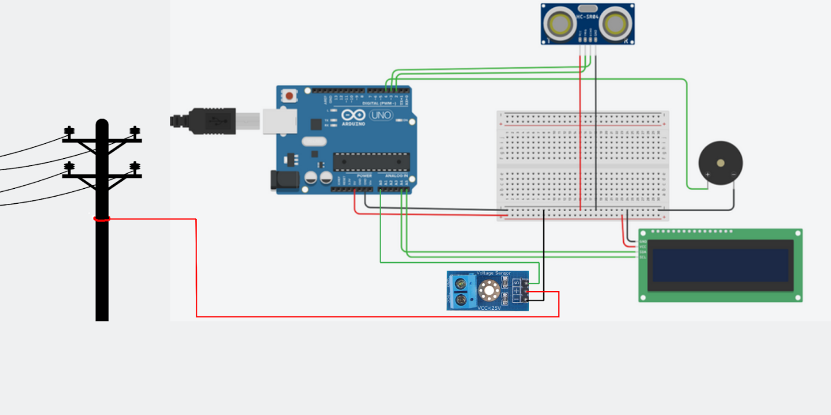

Circuit design

**Description**

The circuit consists of an Arduino Uno connected to a voltage sensor, ultrasonic sensor, buzzer, and LCD display. The voltage sensor detects potential leakage, while the ultrasonic sensor ensures activation of the alert system only when a person is nearby. The Arduino processes the data and triggers the buzzer and LCD alert if both current leakage and high voltage are detected.

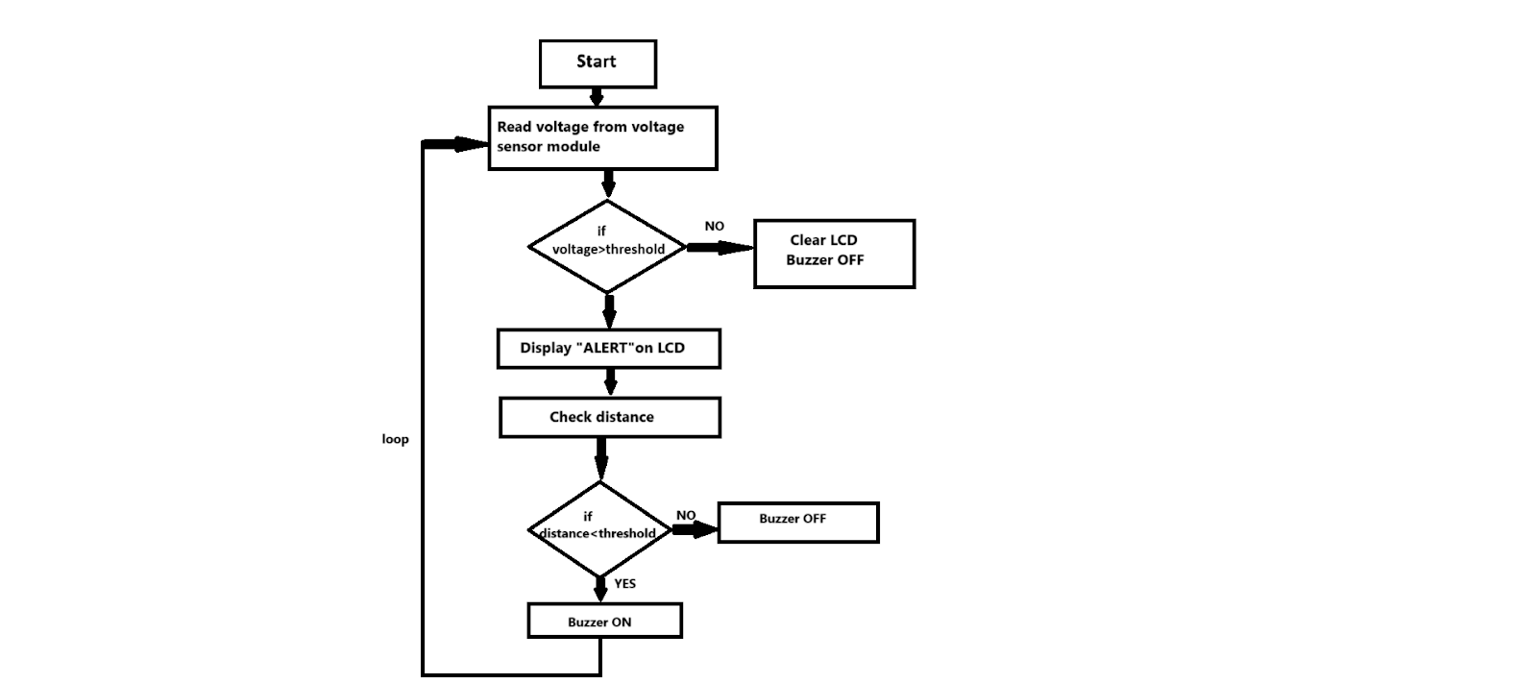

The flowchart represents a step-by-step methodology for a system that monitors voltage and distance, triggers alerts, and activates a buzzer based on threshold conditions. Here's a detailed breakdown:

1. Start: The process begins.

2. Read voltage from the sensor: The system reads the voltage value from a connected sensor.

3. Check if voltage > threshold:

If the voltage is greater than a predefined threshold:

YES: Continue to the next step.

NO: Skip to "Clear LCD, Buzzer OFF."

4. Display "ALERT" on LCD: If the voltage exceeds the threshold, the system displays an "ALERT" message on an LCD screen.

5. Check distance: The system then checks the distance value from another sensor (e.g., an ultrasonic sensor).

6. Check if distance < threshold:

If the distance is below a specific threshold:

YES: The buzzer is turned ON, alerting about the proximity issue.

NO: The buzzer remains OFF.

7. Loop: The process goes back to the beginning to continuously monitor voltage and distance.

8. Clear LCD, Buzzer OFF: If the voltage is below the threshold, the system clears the LCD screen and turns off the buzzer.

This methodology is intended to provide real-time alerts based on specific voltage and distance conditions, ensuring a quick response when necessary.

Q.10 – Any other details you feel are necessary to be included in the Patent Application such as a “Specific Drawings, Code, Description, Tool used”

Ans. –

#include <Wire.h>

#include <LiquidCrystal_I2C.h>

// Define pins for voltage sensor

const int sensorPin = A0;  // Analog pin connected to the voltage sensor

// Define scaling factor and reference voltage

const float scalingFactor = 5.0;     // Scaling factor for 0-25V sensor

const float referenceVoltage = 5.0;  // Arduino reference voltage (e.g., 5V for Uno)

const float voltageThreshold = 0.2;  // Threshold voltage to trigger distance check

// Define pins for ultrasonic sensor

const int trigPin = 2;

const int echoPin = 3;

const float distanceThreshold = 200.0;  // Threshold distance in cm to trigger alert

// Define pin for buzzer

const int buzzerPin = 4;  // Pin connected to buzzer

float cm = 0;             // Store the distance in centimeters

// Function to measure distance using the ultrasonic sensor

long readUltraSonicDistance(int triggerPin, int echoPin) {

  // Set the trigger pin as OUTPUT and send a trigger pulse

  pinMode(triggerPin, OUTPUT);

  digitalWrite(triggerPin, LOW);

  delayMicroseconds(2);            // Ensure it's low for 2 microseconds

  digitalWrite(triggerPin, HIGH);  // Trigger the ultrasonic burst

  delayMicroseconds(10);           // 10 microseconds pulse duration

  digitalWrite(triggerPin, LOW);

  // Set the echo pin as INPUT to receive the reflected signal

  pinMode(echoPin, INPUT);

  return pulseIn(echoPin, HIGH);  // Measure the duration of the echo pulse

}

// Initialize LCD (change address if necessary)

LiquidCrystal_I2C lcd(0x27, 16, 2);  // 16 columns and 2 rows

void setup() {

  // Initialize serial communication for debugging

  Serial.begin(9600);

  // Initialize the LCD

  lcd.begin(16, 2);

  lcd.backlight();

  lcd.setCursor(0, 0);

  lcd.print("Hello");

  // Set up the buzzer pin

  pinMode(buzzerPin, OUTPUT);

}

void loop() {

  // Read voltage from the sensor

  int sensorValue = analogRead(sensorPin);

  float voltage = (sensorValue * referenceVoltage) / 1023.0;

  float actualVoltage = voltage * scalingFactor;

  // Display voltage on the serial monitor

  Serial.print("Voltage: ");

  Serial.print(actualVoltage);

  Serial.println(" V");

  // Check if voltage is above the threshold

  if (actualVoltage > voltageThreshold) {

    // Voltage is high, proceed to check distance

    lcd.clear();

    lcd.setCursor(0, 0);

    lcd.print("Danger: High Voltage!");

    Serial.println("High Voltage ");

    long duration = readUltraSonicDistance(8, 9);

    distance = duration * 0.034 / 2;  // Speed of sound is 0.034 cm/us, divided by 2 for the round trip

    Serial.print("duration :");

    Serial.println(duration);

    // Print the distance to the serial monitor

    Serial.print(distance);

    Serial.println(" cm");

    // Delay before the next reading

    delay(100);

    if (distance > 0 && distance < distanceThreshold) {

      // Object is near, activate buzzer

      // digitalWrite(buzzerPin, HIGH);

      Serial.println("Warning: High Voltage & Object Detected!");

    } else {

      // No object near, turn on LCD to display voltage

      //  digitalWrite(buzzerPin, LOW);

      Serial.println("Voltage High, No Object Near.");

    }

  } else {

    // Voltage is low, do nothing

    // lcd.clear();

    digitalWrite(buzzerPin, LOW);

    Serial.println("Voltage Normal, No Action.");

  }

  // Wait for a short period before next reading

  delay(500);

}